1. 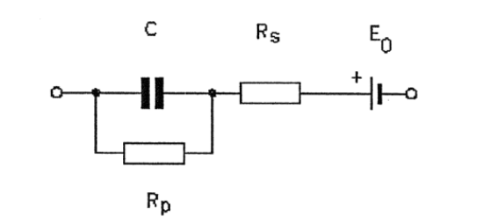  
     
   C: The capacitance across the electrode-electrolyte and the surface layer (example muscle/skin). This capacitance can store charges and could interfere with certain range of signals   
   RP: Polarized resistance, is the resistance between the electrode-electrolyte and the surface of the interested biopotential source.  
   Rs: Series Resistance associated with electrolyte or sometimes electrode.  
   E0 : Half-cell potential, is in essence the voltage difference between the electrode and its reference when no current flows through.
2. By using needle or wire for an invasive electrode we can expect the following:  
   For Capacitance, we can see a decrease in capacitance due to lower surface area of the electrode and a smaller distance between electrode and muscle/nerve, which could lead to lower noise  
   For Rp we can also expect the resistance to be much lower since a lot of layers of skin and other tissues no longer interfere with the signal path. Which should have an increase in Signal to Noise Ratio.   
   E0 may change since electrode potential may now be different, but assuming that electrolyte concentration remains the same there’s probably not a lot of difference. Physiological response to a puncture/wound may have some time dependent changes that might affect the Half cell potential by small amounts.  
   Series potential probably doesn’t change a lot.
3. Diagram

   Description automatically generatedA picture containing text, clock

   Description automatically generatedText

   Description automatically generatedText

   Description automatically generated
4. Text

   Description automatically generatedText

   Description automatically generatedDiagram

   Description automatically generated with medium confidence  
   I didn’t want to simplify and my sketching tablet keeps disconnecting
5. Due to additional Resistance and capacitance the CMMR would be lower and would affected by the frequency as well depending on both Rg and C

Not sure how this would behave and cannot sketch   
slope would be a function of rg and C

1. q7 is on next page.

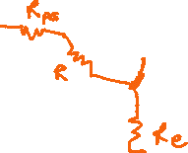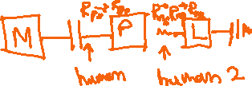

* 1. For the case of nurse, we know that the motor-bed is higher potential since it’s not grounded. The parasitic capacitance would allow the 60hz 120V to flow through.   
       
     In this case it would flow through the patient skin 🡪 patient body 🡪 Catheter 🡪 electrode lead 🡪 nurse skin 🡪 nurse body 🡪nurse skin 🡪 ground (lamp)

The current is too small for any perception for macro shocks,

* 1. In the case of the patient they would get a micro-shock and since this is above the 10μA and also above 60μA threshold, the patient can have fibrillation